# **SUDO PERMISSION ERROR**

1. **Reboot your system in recovery mode (reboot then press and hold esc or shift + esc button to enter in recovery mode)**
2. **Navigate to (advance option for linux) by using down arrow button and press two times Enter**

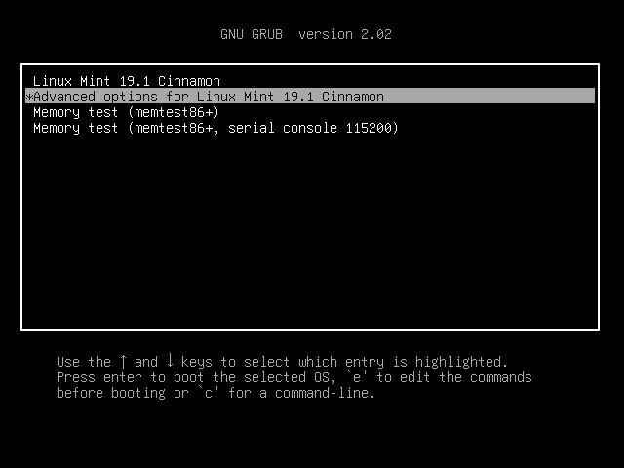

1. **Navigate to root by using down arrow button and press Enter**

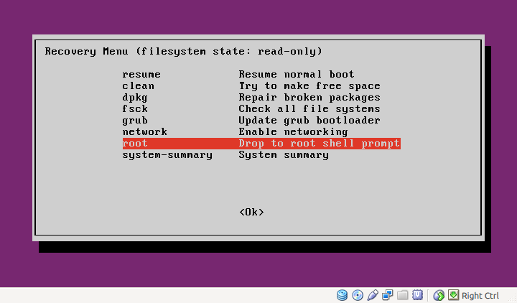

1. **Now enter following commands:**

$ mount -o remount /

$ chown root:root /usr/bin/sudo && chmod 4755 /usr/bin/sudo

$ chown root:root /usr/lib/sudo/sudoers.so && chmod 4755 /usr/lib/sudo/sudoers.so

$chown root:root /var/* && chmod 4755 /var/*

**sudo: /etc/sudoers is world writable**

**sudo: no valid sudoers sources found, quitting**

**sudo: unable to initialize policy plugin**

ls -l /etc/sudoers

**-r--r-----. 1 root root 3822 Sep 12 08:53 /etc/sudoers**

chmod 440 /etc/sudoers

ls -l /etc/sudoers

**-r--r-----. 1 root root 3822 Sep 12 08:53 /etc/sudoers**